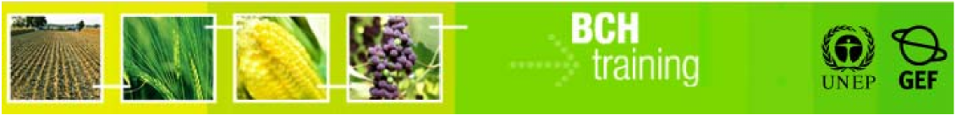

**A User's Guide to the Central Portal of the Biosafety Clearing House**

**“Using the BCH for Customs and Border Control tasks”**

October 2012

**Manual outline**

1. Introduction to the Manual 3

2. Cartagena Protocol on Biosafety to the Convention on Biological Diversity 4

2.1. Introduction to the Cartagena Protocol on Biosafety 4

2.2. The Role of Customs and Border Control Officers in the Implementation of the Protocol 5

3. Customs Officers and the BCH 9

4. Special Activities and Resources on The Biosafety Clearing-House 14

4.1. Portal on the Handling, Transport, Packaging and Identification of Living Modified Organisms 14

4.2. Publications and other outreach materials on the Cartagena Protocol on Biosafety 15

4.3. LMO quick-links 15

4.4. Green Customs Initiative 16

# Introduction to the Manual

**What you will learn in this manual:**

This manual provides a brief introduction to the Cartagena Protocol on Biosafety, outlines some of the Protocol’s key elements of relevance to customs officers, describes the roles of customs officers in the implementation of the Protocol and guides users in how to access information in the Biosafety Clearing-House that is important for customs and border control officers.

**Context**:

The UNEP-GEF Project for Capacity Building for Effective Participation in the Biosafety Clearing-House (BCH-I), in collaboration with the Secretariat of the Convention on Biological Diversity (SCBD), prepared a modular training package aimed at providing a practical “how-to” guide for countries to assist them in learning, understanding, using, and setting up national access to the BCH. The training package was later updated within the UNEP-GEF Project for Continued Enhancement of Capacity Building for Effective Participation in the BCH (BCH-II). It was designed to be flexible and is tailored to meet the diverse needs of different countries, allowing them to select those tools that are most useful to their situation, needs and priorities. The training package is divided into several manuals, each addressing one element of the BCH..

**Audience**

This manual is designed to provide guidance to custom and border control officers users of the BCH at various levels. It is developed for a non-technical audience with little or no knowledge of the Cartagena Protocol on Biosafety and the BCH, but with a need to access and use data on the BCH.

**Purpose**

At the fourth meeting of the government body of the Protocol, the Parties requested more capacity-building support, with special attention to targeted stakeholders (e.g., customs departments and phytosanitary inspectors) (decisions BS-IV/2 and BS-IV/5). This manual was produced in response to that request. The manual complements the General User's Guide to the Central Portal of the Biosafety Clearing House, giving emphasis to issues that are of particular relevance to customs and border control.

# Cartagena Protocol on Biosafety to the Convention on Biological Diversity

|  |  |
| --- | --- |
| cámara | OVERVIEW  The Cartagena Protocol on Biosafety is an international treaty that sets rules for the safe use of living organisms modified through modern biotechnology. The Protocol establishes procedures for making decisions for the import and export of these organisms. |

## Introduction to the Cartagena Protocol on Biosafety

The *Cartagena Protocol on Biosafety to the Convention on Biological Diversity* (“the Protocol”) is an international treaty governing the movements of living modified organisms (LMOs) resulting from modern biotechnology from one country to another. It was adopted on 29 January 2000 as a supplementary agreement to the Convention on Biological Diversity and entered into force on 11 September 2003. More than 160 countries are Parties to the Protocol meaning that they have agreed to be bound by its terms.

The Protocol was negotiated in the context of many countries not having regulatory systems in place to govern the introduction of living modified organisms. These countries were concerned that new organisms could be imported into their territories and introduced into the environment without their prior approval or without them even being aware that this was taking place. Many countries were also concerned about the possible impacts living modified organisms could have on the environment. These concerns included the potential for LMOs to become pests, to out-compete and replace wild relatives, to increase dependence on pesticides or to spread their introduced genes to weedy relatives, potentially creating ‘super-weeds’.

Countries thus sought an international treaty that would assist them in taking decisions on living modified organisms. The result was the Cartagena Protocol on Biosafety.

The objective of the Protocol is to, in accordance with the precautionary approach, contribute to ensuring an adequate level of protection in the field of the safe transfer, handling and use of living modified organisms resulting from modern biotechnology that may have adverse effects on the conservation and sustainable use of biological diversity, taking also into account risks to human health, and specifically focusing on transboundary movements.

A living modified organism is defined in the Cartagena Protocol on Biosafety as any living organism that possesses a novel combination of genetic material obtained through the use of modern biotechnology. In everyday usage, LMOs are usually considered to be the same as GMOs (genetically modified organisms), but definitions and interpretations of the term GMO vary widely. The Protocol is an environmental agreement so it uses the term **living** modified organisms as these are the organisms that may enter the environment and impact biodiversity.

In general, an LMO is made by taking a gene (a piece of DNA) from one organism and inserting it into the DNA of another organism. Scientists search for genes that correspond to desired characteristics. By inserting these genes into other organisms, scientists can create organisms that display the traits coded for by the gene. Most of the LMOs that have been developed to date are agricultural crops that have genes inserted that make them resistant to certain insects or tolerant of different herbicides. Examples of modified crops include maize, soybeans, cotton and canola. These agricultural crops are currently the most widely traded LMOs and so are the LMOs that customs and border control officers are most likely to encounter in their work. Other types of modified organisms that are being developed include salmon modified to grow more quickly and mosquitoes modified to reduce the incidence of dengue fever.

The Protocol establishes various rules and procedures for regulating the transboundary movement of LMOs. These are intended to ensure that LMOs do not adversely affect biological diversity and human health. The Protocol aims to ensure the safety of LMOs, not to prohibit their trade.

The Protocol also establishes an informational exchange system known as the “Biosafety Clearing-House” (BCH). Parties to the Protocol are required to share certain types of information and decisions via the BCH. The BCH will also be useful to the work of customs and border control officers in their roles in implementing the Protocol. More information on these roles is provided in the next section. Chapter 3 of this guide includes more details on the BCH and exercises on how to search for key categories of information.

## The Role of Customs and Border Control Officers in the Implementation of the Protocol

Trade in environmentally sensitive products such as LMOs is a growing global challenge. There is a need for international cooperation to monitor and control the cross-border movement of such products in order to protect the environment and human health. Customs and border protection officers have a crucial role to play in addressing the challenge.

A country importing LMOs may wish to ensure that it has approved the LMOs contained in a shipment for their intended use in order to fulfill the objective of the Protocol.

To do this:

1. The documentation that accompanies a shipment that contains LMOs must identify the shipment as such.
2. The sampling of shipments and the detection of any LMOs contained therein can be used to verify the documentation.
3. The documentation and detection of LMOs in a shipment can be used to check whether the competent national authority has approved the LMOs for their intended used in the country.

Customs and border control officers have four roles to play under the Protocol:

1. Verifying that the necessary identification information has been provided in the accompanying documentation
2. Inspecting incoming shipments of LMOs
3. Verifying that LMOs for import have received necessary approvals
4. Detecting unintentional or illegal transboundary movements.
5. Verifying that the necessary identification information has been provided in the accompanying documentation

The Protocol sets requirements for information that must be included in documentation that accompanies transboundary movements of living modified organisms. These requirements can be found in Article 18 of the Protocol as well as associated decisions of the Conference of the Parties serving as the meeting of the Parties to the Protocol (the governing body of the Protocol.) The information requirements vary depending on the intended use of the LMO. The Protocol distinguishes between different intended uses of LMOs because the different uses pose different risks for biodiversity.

Documentation accompanying LMOs for intentional introduction into the environment must:

* Clearly identify the content as LMOs and briefly describe the organisms (e.g. the name and relevant traits or characteristics of the organism, its unique identifier)
* specify any requirements for the safe handling, storage, transport and use
* list the name and address of the importer and exporter
* provide an emergency contact point
* contain a declaration that the movement is in conformity with the requirements of the Protocol applicable to the exporter
* provide further information, where appropriate, such as the commercial name, risk class and import approval for the LMO.

Documentation accompanying LMOs for direct use as food or feed, or for processing (LMOs-FFP) must clearly state:

* that the shipment “contains LMOs-FFP” where the identity of the LMOs is known
* that the shipment “may contain one or more LMOs-FFP” where the identity of the LMOs is not known
* that the LMOs are not intended for introduction into the environment
* the common, scientific and commercial names of the LMOs
* the transformation event code or its unique identifier (where available)
* the internet address of the Biosafety Clearing-House for further information.

Documentation accompanying LMOs for contained use must:

* clearly identify the content as LMOs and indicate that they are “destined for contained use”
* list the name and address of the consignee, exporter and importer
* specify any requirements for the safe handling, storage, transport and use
* provide further information, where appropriate, such as the commercial name of the LMOs, the new or modified traits, the transformation event, risk class, use and any unique identification code.

### Where can customs officers find information on LMOs in shipping documentation?

The Parties to the Protocol have not adopted a stand-alone document to accompany shipments of LMOs. Instead, the information that is to be provided will be included in existing types of shipping documentation such as invoices, bills of lading, way bills, etc. The practice of the grain trade industry is to include the required information in the invoice as this is the one document that accompanies all shipments.

### Inspecting incoming shipments of LMOs

When a shipment of LMOs arrives at a border or customs control point, customs officers should follow their country’s rules and procedures regarding inspection of the shipment to verify its content and cross-check against the accompanying documentation.

It is generally not possible to visually distinguish a living modified organism from a conventional organism so verifying the content of a shipment will require collecting a sample from the shipment and testing it to determine what, if any, LMOs it contains.

The Protocol does not set specific requirements for methods for the sampling of shipments and detection of LMOs. Countries will need to set their own rules and procedures regarding how to collect a sample from a shipment and what testing procedures to follow to determine whether a sample contains LMOs and if so, which LMOs and in what quantities. Customs officers will likely need to cooperate with other government agencies involved in this type of work at the border, e.g. health or phytosanitary inspectors and associated laboratories.

Customs officers also need to ensure that shipment of LMOs are handled, stored and packaged according to any applicable requirements specified in the shipping documentation.

### Verifying that LMOs for import have received the necessary approvals

Either on the basis of the LMOs identified in the shipping documentation or on the basis of the LMOs identified through testing, customs officers can use the BCH to verify whether these organisms have received the necessary approvals for import into their country.

In point *i* above, the information to be included in documentation accompanying LMOs intended for different types of uses made reference to ‘unique identifiers’ or ‘unique identification codes’. To date, only one system of unique identification has been developed: the Organisation for Economic Cooperation and Development’s (OECD) Unique Identifiers for Transgenic Plants.

The OECD Unique Identifier is a simple alphanumeric code that is given to each living modified plant that is approved for commercial use. Developers of transgenic plants are the ones to assign the unique identifier to a new type of modified plant.

Under this system, a unique identifier is a 9-digit code composed of three elements separated by dashes:

* 2 or 3 alphanumeric digits to designate the applicant
* 5 or 6 alphanumeric digits to designate the transformation event
* 1 numerical digit for verification.

Example: MON-00810-6 is the unique identifier for Monsanto’s YieldGard maize, a type of maize that has been modified to be resistant to a ceratin insect, the European corn borer.

As will be seen in chapter 3 below, we can use unique identifiers as a simple way to search the BCH to find information and countries’ decisions on the LMO.

### Detecting unintentional or illegal transboundary movements

The Protocol also addresses unintentional and illegal transboundary movements.

Unintentional transboundary movements could occur through such means as gene flow as part of natural plant reproduction processes, or accidental contamination due to a spill while a shipment is in transit. To help prevent unintentional transboundary movements, customs officers need to follow the requirements for the handling, storage, transport and use of the LMOs that should be indicated in the shipping documentation. If a spill occurs or you detect an unintentional transboundary movement, you should contact your country’s competent national authority under the Protocol (see the exercise in chapter 3 on how to find their contact information in the BCH.)

The Protocol defines an illegal transboundary movement of an LMO to be a transboundary movement that is carried out in contravention of domestic measures to implement the Protocol (Article 25). Customs officers will need to be familiar with their national biosafety laws in order to know what constitutes an illegal transboundary movement. If you detect an illegal transboundary movement, you should immediately inform your country’s competent national authority. Parties to the Protocol have an obligation to make available to the BCH information concerning cases of illegal transboundary movements pertaining to them.

# Customs Officers and the BCH

|  |  |
| --- | --- |
| cámara | OVERVIEW  The Biosafety Clearing-House is a mechanism set up by the *Cartagena Protocol on Biosafety* to facilitate the exchange of information on living modified organisms and assist the Parties to implement their obligations under the Protocol. |

The Biosafety Clearing-House provides global access to a variety of scientific, technical, environmental, legal and capacity building information in the six United Nations languages (Arabic, Chinese, English, French, Russian and Spanish). The BCH is free and available to everyone.

The BCH can be accessed at: <http://bch.cbd.int>. Figure 1 shows the home page or “Central Portal” of the BCH.

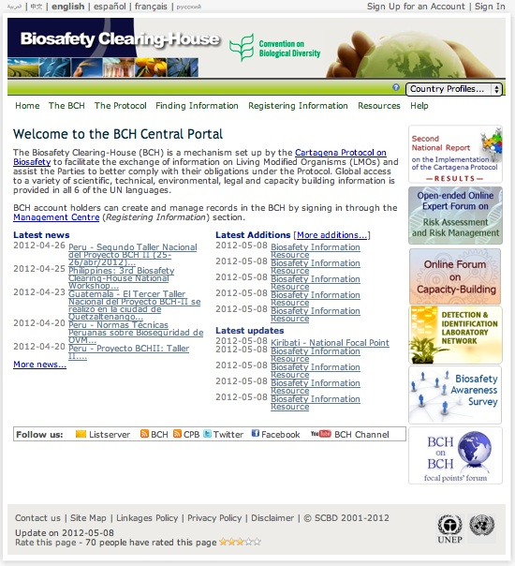

Figure 1 The BCH Central Portal

The information in the BCH is organized into two categories: a) **National Records** submitted by Governments as mandated by Article 20 of the Protocol and b) **Reference Records** which are submitted by general BCH users.

The most common types of information that customs officers are likely to need to find in the BCH are:

* Contact information for national authorities
* National decisions on whether or not the import of specific LMOs is allowed.

|  |  |
| --- | --- |
| mouse | Exercise 1: Finding a national contact |

|  |  |
| --- | --- |
| huellas | Exercise 1: Solution  From the ‘Finding information’ section of the BCH, choose to search the ‘National Contacts’ database. Then enter your search criteria and click the ‘search’ button. Figure 2 shows an example of searching for India’s competent national authorities. |

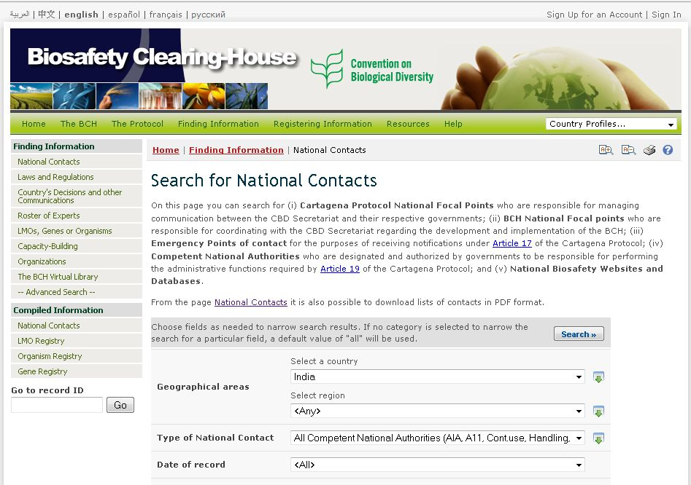

Step 4

Step 3

Step 2

Step 1

Figure 2 Search National Contacts

The result of the search should be a list of one or more records. You can then click on the records to find the contact information and details you are looking for.

As described in section B above, one of the roles of customs officers in the Protocol is verifying that LMOs for import have received the necessary approvals. Once you know what LMOs are in a shipment – either through the identification information provided in accompanying documentation or through sampling and detection – you can use this information to search the BCH for countries’ decisions.

In many cases, shipments of living modified plants, including grains and seeds, will be identified in shipping documentation through their unique identifiers. An overview of the existing system of unique identifiers for transgenic plants was provided in chapter 2. We can use unique identifiers as an easy way to search the BCH.

|  |  |
| --- | --- |
| mouse | Exercise 2: Finding a country’s decision on an LMO by searching with the unique identifier |

|  |  |
| --- | --- |
| huellas | Exercise 2: Solution  From the ‘Finding information’ section of the BCH, choose to search the ‘LMOs, Genes or Organisms’ database. In the first drop-down menu for ‘Registries’, choose the ‘LMO-Unique Identifiers Registry (LMO-UIds)’. Under ‘type of living modified organism’, choose to filter by unique identifier. A new drop-down menu will appear in which you will find a list of all the unique identifiers that have been made available to the BCH. Select the unique identifier you are looking for and click ‘search’. Figure 3 shows an example of searching for MON-00810-6, the unique identifier for Monsanto’s YieldGard maize. |

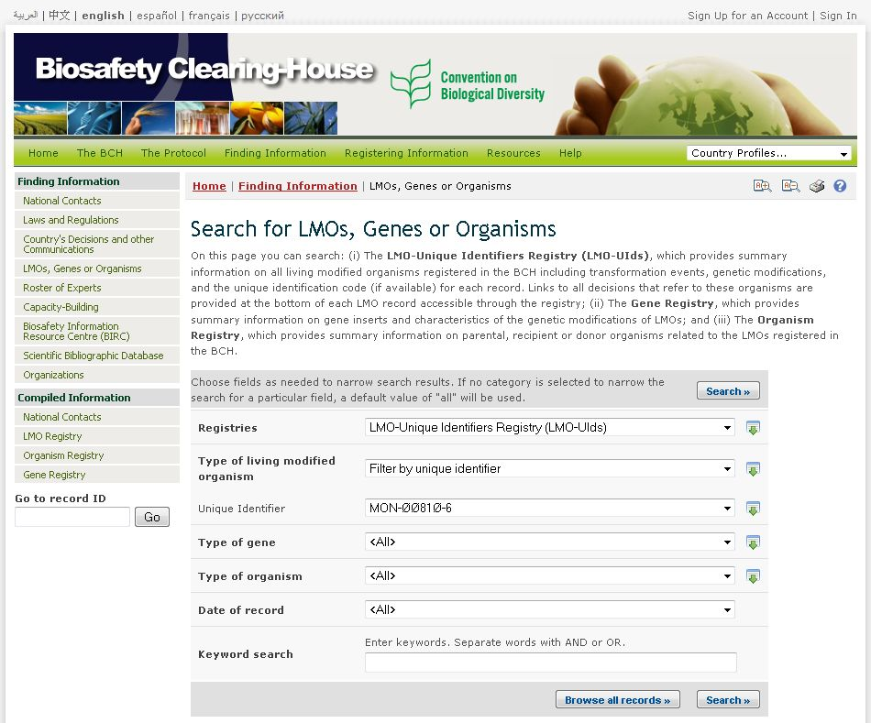

Step 4

Step 3

Step 2

Step 1

Figure 3 – Searching information

The result of the search should be the record for YieldGard maize. Clicking on the record will bring you to a page providing information on the LMO. This includes a section on detection methods. At the top of the record, you can choose to view ‘Decisions on the LMO’. This will bring you to a table of countries that have taken a decision on this specific LMO and submitted the decision to the BCH, as you can see in Figure 4.

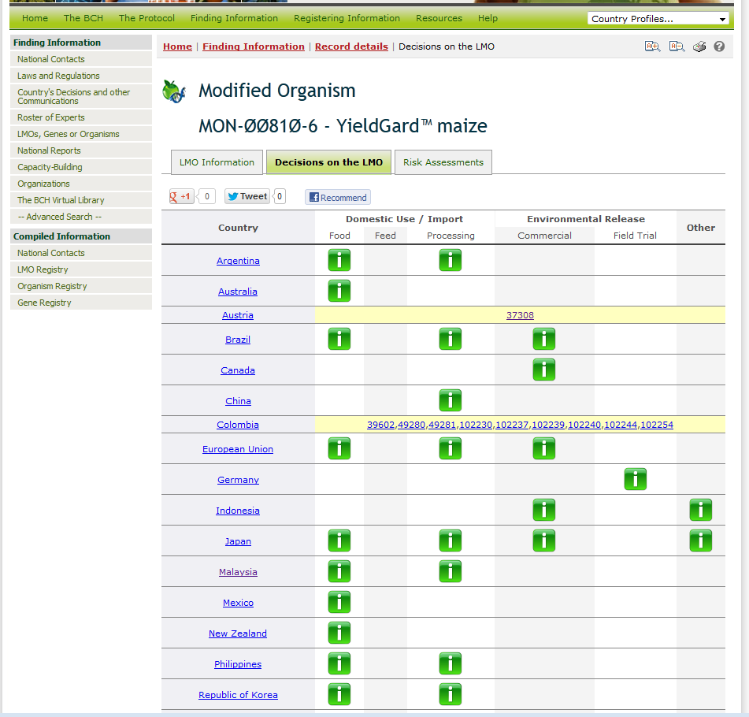

Figure 4 Decisions

A green box with the letter ‘i’ in it provides a link to the country’s decision and indicates the type of use of the LMO that is considered in the decision, i.e. whether it is for domestic use of the LMO for food, feed or processing; for import for food, feed or processing; for environmental release; or other. Clicking on the green box will bring you to the record for the decision where you can see the result of the decision, i.e. whether or not the import or use of the LMO has been approved and whether there are any conditions on an approval.

In some cases, you will see that the record is highlighted in yellow. This means that classification is pending because the record does not specify which use of the LMO has been considered in the decision. A link is provided to access the decision.

One thing to note, however, is that because the system of unique identifiers only applies to plants, if a shipment contains a different type of LMO such as a fish or a micro-organism, the accompanying documentation will not contain a unique identifier and customs officers will need to search for their country’s decisions using other search features of the BCH. Other ways to search for decisions include filtering by the organism’s common name or accessing a country’s profile to see all the decisions taken by the country.

# Special Activities and Resources on The Biosafety Clearing-House

|  |  |
| --- | --- |
| cámara | OVERVIEW  Special activities and resources on the BCH relevant for customs officers include:   * the Portal on the Handling, Transport, Packaging and Identification of Living Modified Organisms * publications and outreach materials on the Cartagena Protocol on Biosafety * LMO quick-links * Training Materials * The Green Customs Initiative |

## Portal on the Handling, Transport, Packaging and Identification of Living Modified Organisms

This Portal is home to ongoing discussions and work on the handling, transport, packaging and identification of living modified organisms under the Cartagena Protocol on Biosafety.

The Portal includes a section for customs officials where additional documents and resource materials are available. Many of these materials are from a series of training of trainers workshops on the identification and documentation of living modified organisms under the Cartagena Protocol on Biosafety that were organized between 2009 and 2011. The materials provide additional information on the Protocol and the BCH, the sampling, detection and identification of LMOs and national experiences with transboundary movements of LMOs. The information is available via <http://bch.cbd.int/onlineconferences/portal_art18/htpi_customs.shtml>.

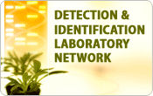The Portal also includes an electronic network of LMO detection and identification laboratories. Activities and discussions are ongoing as part of this network to enable the sharing of information and experiences among laboratories and to facilitate the identification of LMOs.

|  |  |
| --- | --- |
| mouse | Exercise 3: Find LMO detection and identification laboratories in your region |

|  |  |
| --- | --- |
| huellas | Exercise 3: Solution   1. From BCH Home page, select ‘Organizations’ in the *Finding information* drop-down menu. 2. Select your regional group in the *Select geographical region(s) or political/economic group(s)* search field and “Laboratory for detection and identification of LMOs” in *Type of organization* search field.   3. Press the Search button. |

## Publications and other outreach materials on the Cartagena Protocol on Biosafety

A variety of publications on the Protocol have been prepared. These include:

* Fact sheets and banners on different aspects of the Protocol: <http://bch.cbd.int/protocol/cpb_factsheets.shtml>
* A series of videos available on the BCH YouTube channel: <http://www.youtube.com/user/bchcpb>
* An issue of the Biosafety Technical Series on “Standards for Shipments of Living Modified Organisms”: <http://bch.cbd.int/protocol/cpb_technicalseries.shtml>

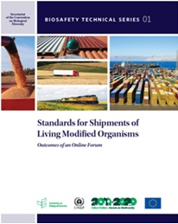

The issue of the Biosafety Technical Series on “Standards for Shipments of Living Modified Organisms” includes a summary of standards and standard-setting processes relevant to the handling, transport, packaging and identification of LMOs including in the context of the Codex Alimentarius Commission, the International Plant Protection Convention, the United Nations Recommendations on the Transport of Dangerous Goods, Model Regulations and the World Customs Organization.

## LMO quick-links

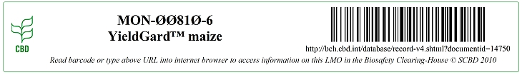

*LMO Quick-links* are small image files, which can be easily copied and pasted, that identify an LMO through its unique identifier, trade name and a link to the BCH where information on the LMO is available (e.g. LMO characteristics, countries' decisions, risk assessments, etc.). Through the *LMO Quick-links,* the BCH page can be easily accessed by either scanning the barcode or by typing the URL in a web browser. The Quick-links are available for dowload at <http://bch.cbd.int/resources/quicklinks.shtml>. You can also watch a video for more information on the Quick-links and how they can be used.

|  |  |
| --- | --- |
| mouse | Exercise 4: Find LMO quick-link for MON-ØØ81Ø-6 - YieldGard maize |

|  |  |
| --- | --- |
| huellas | Exercise 4: Solution   1. From the BCH home page, select “LMO quick-links” in the **Resources** drop-down menu 2. Once you’ve reached the “LMO quick-links” page, select “MON-ØØ81Ø-6 - YieldGard™ maize” from the “LMO Quick link for downloading” drop-down menu. |

## Green Customs Initiative

The Green Customs Initiative is a partnership of international organizations cooperating to prevent the illegal trade in environmentally-sensitive commodities and to facilitate the legal trade in these.

Its objective is to enhance the capacity of customs and other relevant enforcement personnel to monitor and facilitate the legal trade and to detect and prevent illegal trade in environmentally-sensitive commodities covered by the relevant conventions and multilateral environmental agreements. These include ozone depleting substances, toxic chemical products, hazardous wastes, endangered species and living modified organisms.

The Cartagena Protocol on Biosafety is one of the partners in the Green Customs Initiative. A number of tools have been developed under the Green Customs Initiative. These include a Guide to Multilateral Environmental Agreements, an introductory video on the Initiative as well as other training materials from some of the different partners. These are available via the Green Customs website: <http://www.greencustoms.org> as well as through the BCH.